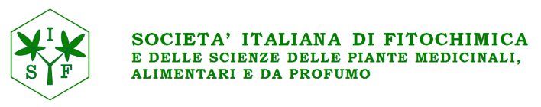

Scuola SIF “Paolo Ceccherelli”
METABOLOMICS IN NATURAL PRODUCT RESEARCH
From biomarker discovery to deep metabolome analysis and targeted isolation of bioactive compounds

da inviare per e-mail entro il 10/07/2023 a: Elisabetta Monni segreteria.sif@gmail.com

DATI PARTECIPANTE

COGNOME____________________________________________________
NOME________________________________________________________
ENTE_________________________________________________________
INDIRIZZO____________________________________________________
CITTÀ_______________________________________CAP______________
TEL__________________________________________________________
E-MAIL_______________________________________________________

□ Socio SIF
□ non Socio SIF
□ studente / non strutturato
□ richiesta Borsa di Studio

